# Exercises: Entity Relations

This document defines the **exercise assignments** for the ["Databases Advanced – EF Core" course @ Software University](https://softuni.bg/trainings/1741/databases-advanced-entity-framework-october-2017).

## Student System

Your task is to create a database for the **Student System**, using the **EF Core Code First** approach. It should look like this:

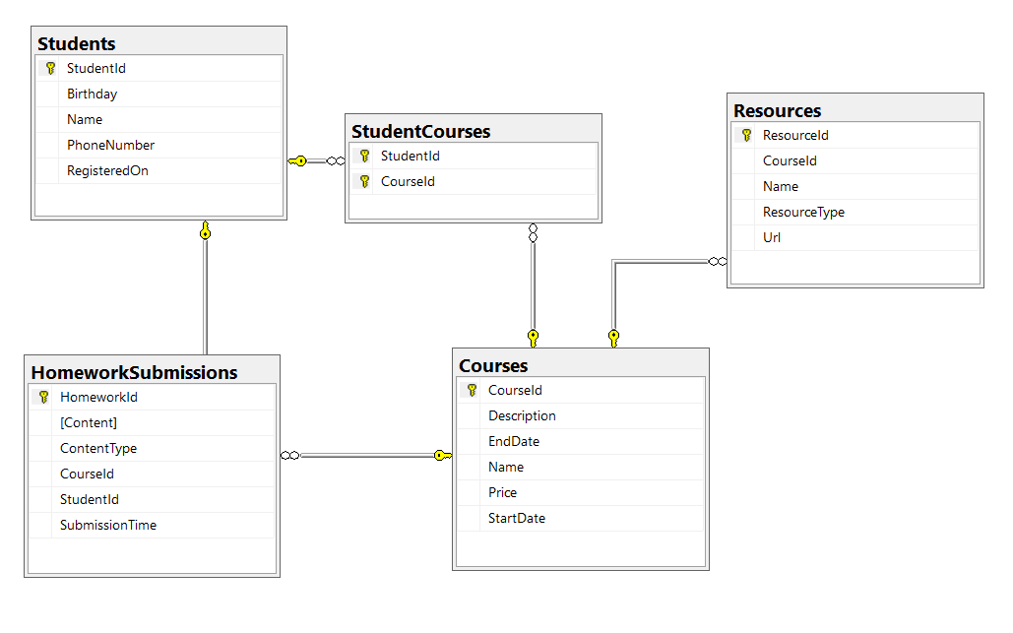

### Constraints

Your **namespaces** should be:

* P01_StudentSystem – for your Startup class, if you have one
* P01_StudentSystem.Data – for your DbContext
* P01_StudentSystem.Data.Models – for your models

Your **models** should be:

* StudentSystemContext – your DbContext
* Student:
  + StudentId
  + Name (up to 100 characters, unicode)
  + PhoneNumber (exactly 10 characters, not unicode, not required)
  + RegisteredOn
  + Birthday (not required)
* Course:
  + CourseId
  + Name (up to 80 characters, unicode)
  + Description (unicode, not required)
  + StartDate
  + EndDate
  + Price
* Resource:
  + ResourceId
  + Name (up to 50 characters, unicode)
  + Url (not unicode)
  + ResourceType (enum – can be Video, Presentation, Document or Other)
  + CourseId
* Homework:
  + HomeworkId
  + Content (string, linking to a file, not unicode)
  + ContentType (enum – can be Application, Pdf or Zip)
  + SubmissionTime
  + StudentId
  + CourseId
* StudentCourse – mapping class between **Students** and **Courses**

Table relations:

* **One student** can have **many CourseEnrollments**
* **One student** canhave **many HomeworkSubmissions**
* **One course** can have **many StudentsEnrolled**
* **One course** can have **many Resources**
* **One course** can have **many HomeworkSubmissions**

You will need a constructor, accepting **DbContextOptions** to test your solution in **Judge**!

## Seed Some Data in the Database

Write a **seed method** that fills the database with sample data.  
Fill a few **students**, **courses**, **resources** and **homework submissions**.

#### Bonus

Create a console application that reads information about **courses** and **students**.

## Football Betting

Your task is to create a database for a **Football Bookmaker System**, using the **Code First** approach. It should look like this:

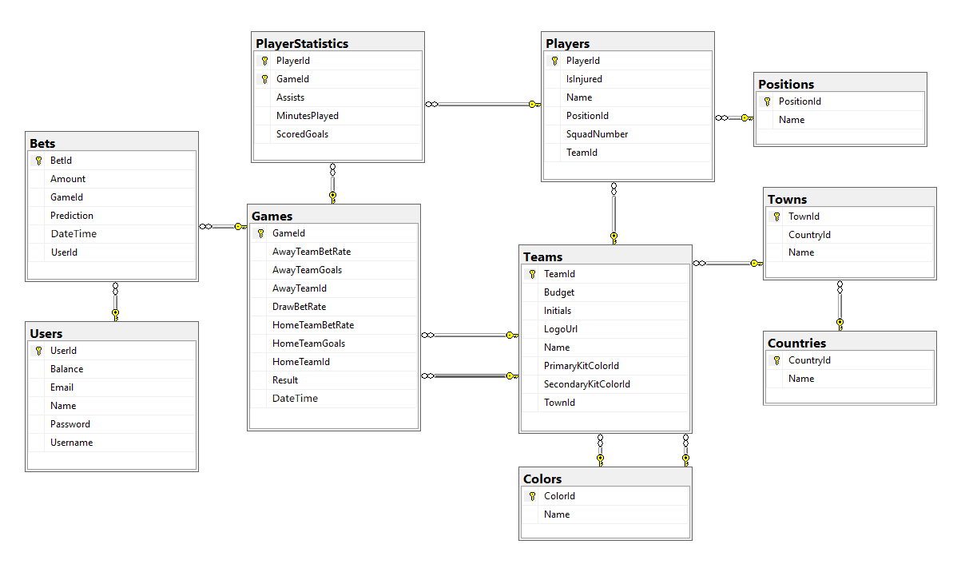

### Constraints

Your **namespaces** should be:

* P03_FootballBetting – for your Startup class, if you have one
* P03_FootballBetting.Data – for your DbContext
* P03_FootballBetting.Data.Models – for your models

Your models should be:

* **FootballBettingContext** – your DbContext
* **Team** – TeamId, Name, LogoUrl, Initials (JUV, LIV, ARS…), Budget, PrimaryKitColorId, SecondaryKitColorId, TownId
* **Color** – ColorId, Name
* **Town** – TownId, Name, CountryId
* **Country** – CountryId, Name
* **Player** – PlayerId, Name, SquadNumber, TeamId, PositionId, IsInjured
* **Position** – PositionId, Name
* **PlayerStatistic** – GameId, PlayerId, ScoredGoals, Assists, MinutesPlayed
* **Game** – GameId, HomeTeamId, AwayTeamId, HomeTeamGoals, AwayTeamGoals, DateTime, HomeTeamBetRate, AwayTeamBetRate, DrawBetRate, Result)
* **Bet** – BetId, Amount, Prediction, DateTime, UserId, GameId
* **User** – UserId, Username, Password, Email, Name, Balance

Table relationships:

* **A Team** has one **PrimaryKitColor** and one **SecondaryKitColor**
* **A Color** has **many PrimaryKitTeams** and **many SecondaryKitTeams**
* **A Team** residents in one **Town**
* **A Town** can host **several** **Teams**
* **A Game** has one **HomeTeam** and one **AwayTeam** and a **Team** can have **many** **HomeGames** and **many** **AwayGames**
* **A Town** can be placed in **one** **Country** and a **Country** can have many **Towns**
* **A Player** can play for **one** **Team** and **one** **Team** can have many **Players**
* **A Player** can play at one **Position** and one **Position** can be played by **many** **Players**
* **One** **Player** can play in **many** **Games** and in each **Game**, **many** **Players** take part (both collections must be named PlayerStatistics)
* **Many** **Bets** can be placed on **one** **Game**, but **a** **Bet** can be only on **one** **Game**
* Each bet for given game must have **Prediction** result
* **A Bet** can be placed by only **one** **User** and one **User** can place many **Bets**

Separate the **models**, **data** and **client** into **different layers** (projects).